iPhone Brands
Student Name
Institution Affiliation
Date

iPhone Brands
Description
iPhone introduced its first-generation brand in January 2007 (Official Apple Support, 2020). The product and the strategy of the company are apparent. This company has been able to produce high-end smartphones consistently for 12 years, which focuses on the experience of the market (Haselton,2015). Apple was not the first company to create the first smartphone with a touch screen, email, and web features. However, the iPhone provides an excellent experience to consumers compared to other products which give the reason why it has a vast number of consumers who prefer lining up for hours to get new versions of the phone after release. iPhone, as compared to other products from different companies, was not intended to fit in all the social classes in the market (Gokey, 2019). Between 2007 and 2019, iPhone has made radical profits consistently due to its sales.
According to Holst (2020), the iPhone sold 20% of the total number of smartphones globally in 2019 fourth quarter of the year. Since 2009, it has been among the top five phones. Due to the decline of RIM and Nokia, the presence of the market for the iPhone developed. It has been the competitor of Samsung and has been able to maintain the second position of the highest smartphone brands globally from 2012. Between 2014 and 2017, the sales increased consistently from 170 to 216 million units (Depken& Gregorius, 2008). This influenced the enhancement of phones into the market. The growth of the market for the product is attributed to iPhone 6, 6s, 8, 8s, and iPhone X. This has led to the improvement of the sales consistently.
This image below shows the characteristics of the iPhone 6 brands, which are older models. From the picture, it is evident that the model is not well developed in its features compared to the latest models. The phone is small in size compared to the iPhone 11 models. From the rearview, it is sure that the camera system of the older models was not developed compared to the recent versions.
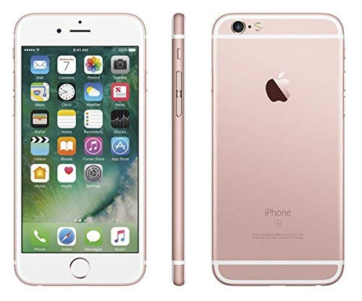
Retrieved from: https://www.google.com/imgres?imgurl=https%3A%2F%2Ffdn2.gsmarena.com%2Fvv%2Fbigpic%2Fapple-iphone-5se-ofic.jpg&imgrefurl=https%3A%2F%2Fwww.gsmarena.com%2Fapple_iphone_6-6378.php&tbnid=4uu-1V3wnH6csM&vet=12ahUKEwjXktGupc_nAhUDw4UKHaTHBZYQMygyegUIARCMAQ..i&docid=HsrgMTXKuY5zvM&w=160&h=212&q=iphone%206%20features&ved=2ahUKEwjXktGupc_nAhUDw4UKHaTHBZYQMygyegUIARCMAQ

The sales of iPhones in 2019 was consistent with sales of up to 12% of global smartphone sales. This was influenced by the release of iPhone XS, XS Max, and XR (Global Smart Phone Market Share, 2019). Between the version of the first product up to now, the iPhone product cycle has been consistent. This is due to the production of the newly redesigned model of the phone every two years with midcycle upgrades amid the redesigned models. This technique has enabled to convince the consumers to upgrade their smartphones by purchasing the new model of the existing phones. The primary method that enhances the demand for the iPhone in the market is through a designed way of pricing the products.
The price of the brands depends on their qualities. The main feature that is considered for pricing the phone is the storage capacity of the phone. For example, iPhone SE, which is the smallest of the brands, is sold at $349 with a capacity of 32GB while $449 for the one with 128GB(Macedonia, 2007). iPhone 11 pro-Max, which is the newest version, is sold at $1099with a capacity of 256 GB (Official Apple Support, 2020). Recently, iPhone 11, 11 Pro, and 11 Max have made a significant change because of their sales. These brands are potential brands in the current market. The prices for iPhone 11, 11 Pro, and 11 Pro Max ranges at $699, $999, and $1,099, respectively.
This image below reveal the price of the latest iPhone models in the market. iPhone 11 pro max is the newest model among the three, which has the highest amount of $1099. The three models have almost the same features to a level that one cannot distinguish them physically. But for people who are sensitive to technology, they can know their differences in operations.

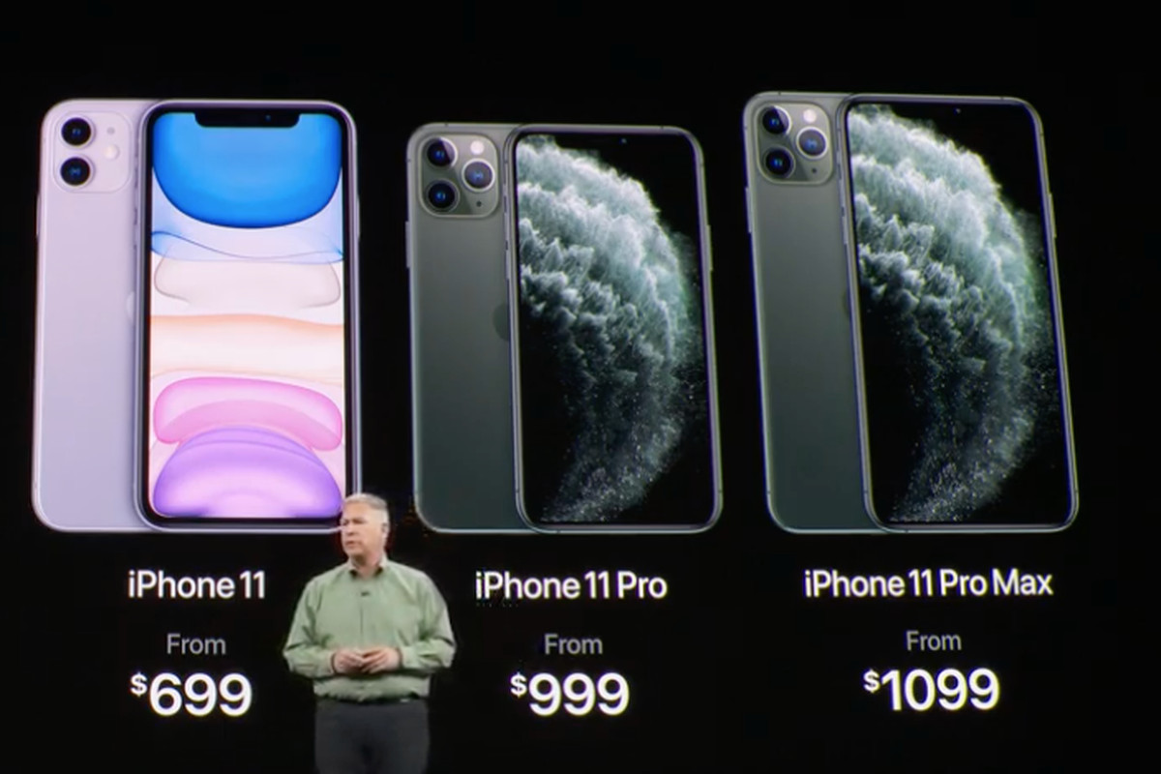
Retrieved from: https://www.theverge.com/2019/9/11/20847304/apple-iphone-11-pro-max-comparison-best-specs-features-price-size-camera
This image below reveals the features of the recent iPhone model (iPhone 11 pro max). The phone is made of aluminum glass material. The camera system is well developed compared to older models like the iPhone 6. The rearview reveals ultra-wide cameras, which is technological advancement.
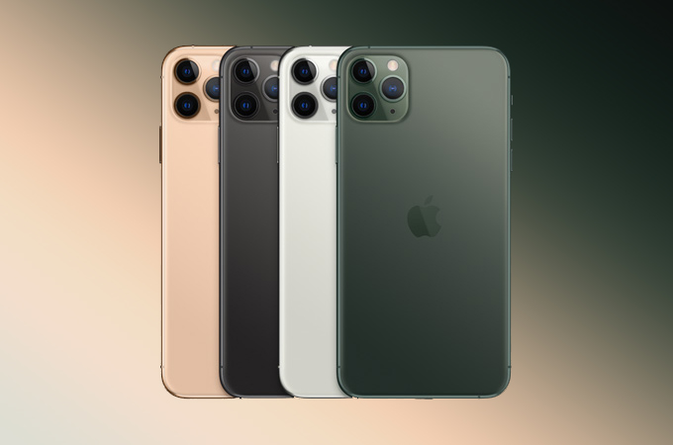

Retrieved from: https://www.google.com/imgres?imgurl=https%3A%2F%2Fwww.apple.com%2Fv%2Fiphone-11-pro%2Fa%2Fimages%2Fmeta%2Fog__smc3haxsdn2q_specs.png%3F201910140529&imgrefurl=https%3A%2F%2Fwww.apple.com%2Fke%2Fiphone-11-pro%2Fspecs%2F&tbnid=KIae_zN-WZDdlM&vet=12ahUKEwjG-f75o8_nAhXH_IUKHS91D8oQMygCegUIARDsAQ..i&docid=yE4n2b4rixfbqM&w=1200&h=630&q=iphone%2011%20pro%20max%20features&ved=2ahUKEwjG-f75o8_nAhXH_IUKHS91D8oQMygCegUIARDsAQ

Recommendations
The iPhone brands have developed to various novel models such as the iPhone 11, 11 Pro, 11 Pro Max, XR, XS, 8, and 8 plus, from other older models. The newer models (11, 11 Pro, and 11 Pro Max) have the recent technologies which vary with a slight difference, which makes them challenging for the consumers to choose the best option concerning the cost-effectiveness of the brand (Amazon, 2020). iPhone 11 costs reasonably at $699, but it has the essential features in the latest model processor. iPhone 11 Pro and 11 Pro Max are suitable for people who are technology addicts who prefer the best. This could work well for those individuals who love ultimate camera technologies. For those people who want large phones, Pro Max is the best choice, while those who love small size phones, 11 pros will be the best option. iPhone XR is also the right choice due to its lower price of $599 (Macedonia, 2007). XS and XS Max are also a good deal, but it is better to consider the iPhone 11, which has a vast number of features and is sold at a considerable price. iPhone X, 8, and 8 plus are good options(Depken& Gregorius, 2010). However, comparing these models, it is better to choose iPhone XR is the better choice within the same budget due to the presence of better technology it possesses compared to the former brands. When considering to purchase an iPhone brand, it is essential to weigh different factors. It is necessary to break down the budget and the needs to ensure the purchase of the best option concerning the situation at hand. It is imperative to know which brands to choose to avoid spending more cash on outdated brands.
There are vital factors to consider before making a choice on which iPhone to purchase. It is essential to consider the RAM and the processor of the phone (Depken& Gregorius, 2010). This feature is critical for ensuring that the phone can perform tasks that are intense such as multitasking and gaming. The processing power of iPhones is better with the new versions than the old ones. Thus, iPhones that were developed three years ago and older are not recommended. Another critical factor is the storage of the phone. This determines the number of apps, songs, videos, and photos the phone can accommodate. iPhone with 16GB is not recommended as it runs out of space within no time (Haselton,2015). The newest model of phones like iPhones 11 has minimal storage of 64 GB, which is recommendable. It is significant to consider battery life. Small iPhones have miserable battery life. iPhone 11 Pro Max is considered to possess the best battery life. It is essential to consider the price of the gadget before purchasing it.
Moreover, it is significant to consider the purchasing of iPhone as a venture as the device is more than just a tool for communication. A phone is a camera, a gaming device, a music player, an album of photos and a computer. Cheap gadgets will get outdated very quickly and will not last for long, which will make the consumer spend more in the long run. Spending $1000 on iPhone 11 Pro Max is less considering that the phone will last for five years and will deliver the best services (Haselton, 2015). Therefore, the best brands to purchase are newer brands that provide a vast amount of high-tech services compared to older versions like iPhone 5 (Gokey, 2019). However, it is vital to consider the budget and the needs of the phone. If one does not require high-end technology, older versions like iPhone 8 can do best for them, which is affordable. For the newest models, the iPhone 11 is the most recommendable brand(Depken& Gregorius, 2010). This is because it is cost-effective, and it offers a vast number of features that are present in the iPhone 11 Pro and 11 Pro Max. The discrepancies between them are very minimal; thus, buying iPhone 11 will save money, and the need of the consumer will be met. Hence iPhone 11 is the best brand overall, 11 Pro is a small high-tech model, 11 Pro Max is the best model, iPhone XR is the best budget model, XS is a short model for less cash, and XS Max is a big phone which is cost-effective.
The credibility of the Sources
The most significant source use in this paper is Official Apple Support. This website provides information on the products that are produced by the apple company. The products are described and displayed for the customers to view their features and make orders. This source was retrieved through the critical word "iPhone." It is a credible source because it is the website of the company which provides the correct information about the iPhones' brands, features, and prices. This website contains updated information on the products (Official Apple Support. (2020). The site has ratings and reviews of the products where the buyers present their experiences concerning different products. The report helps to know how the products are faring in the market.
Statista.com was also used to retrieve information about the market share of the iPhones globally. This website was retrieved via the search engine using the keyword "iPhone market share." This source provides information about the market share of the iPhones compared to other products like Samsung (Holst, 2020). It also gives information about sales that the apple company made in many years. This source is credible as it provides the most recent data related to the market share of the iPhone products. Statista is known to be a trustworthy website that provides reliable information that is retrieved through research. The information in this source is not biased as the researchers are not interested in gaining from the data, thus providing the correct data.
Counterpoint research website provides information on the market share of all the smartphone products from different companies worldwide. This source was retrieved by searching the market share of the iPhone in the search engine. It provides information on the global picture of the market share for the iPhone brands compared to other smartphones. This source is credible as it includes information that is up to date and can conclude the information concerning the market share of the iPhone brands in comparison with other phones like Samsung, Huawei, Oppo, Xiaomi, among others (Global Smartphone Market Share, 2020) . This source provides information that is not biased. This research company includes information on the tech industry, which is done without any aim of personal gains. This firm has experienced researchers who have been in the analysis sector for an extended period.
Amazon was also used to retrieve information about the price of different iPhone products. This is a website where various products are displayed to enable people to retrieve information on different products that are sold online. It allows the consumer to get information on different products and their features, thus making orders for these products. This site provides information on various iPhone models, their characteristics, and price (Amazon, 2020). It is a credible source that contains information that was important for this paper. It includes data that is not biased as it is a business entity that sells products globally.
Business insider.com was also used to write this paper. The source was retrieved through searching for the best iPhones in the search engines. This site publishes factual information. It is a trustworthy source that has influenced this paper by providing information on different options that can be considered while choosing the iPhone brand to purchase (Gokey, 2019). The author of this site, Malarie Gokey, is a known editor who is experienced in writing information about consumer technology in different products.
Conclusion
iPhone products are of good quality with a range of high-tech features that are significant for the interest of consumers in the current world. However, they are more expensive compared to other smartphones from various companies that produce smartphones that have almost similar features. This has made the products to be seen as 'high-class gadgets' which influences people who are wealthy to purchase them. Moreover, phones are also purchased by other people who believe in technology regardless of their social class(Depken& Gregorius, 2010). iPhones do not disappoint, especially the new model due to their feature. When buying an iPhone, it is essential to consider the budget and the need for the phone. The latest version of iPhones is the best. However, iPhone 11 is much recommended than 11 Pro and 11 Pro Max when putting the budget into consideration. This is because it has almost the same features as the others, and it is cheaper. For people who are concerned with technological advancement, iPhone Pro Max is the best option.

References
Amazon.com: Apple - Unlocked Cell Phones / Cell Phones: Cell Phones & Accessories. (2020). Retrieved 10 February 2020, from https://www.amazon.com/Unlocked-Cell-Phones-Apple/s?rh=n%3A2407749011%2Cp_89%3AApple
Depken, C., & Gregorius, B. (2008). Auction Characteristics, Seller Reputation, and Closing Prices: Evidence from eBay Sales of the iPhone. SSRN Electronic Journal. doi: 10.2139/ssrn.1096206
Depken, C., & Gregorius, B. (2010). Auction characteristics, seller reputation, and closing prices: evidence from eBay sales of the iPhone. International Journal of Electronic Business, 8(2), 170. doi: 10.1504/ijeb.2010.032094
Global Smartphone Market Share: By Quarter - Counterpoint Research. (2020). Retrieved 10 February 2020, from https://www.counterpointresearch.com/global-smartphone-share/
Gokey, M. (2019). Business Insider. Retrieved 10 February 2020, from https://www.businessinsider.com/author/malarie-gokey?IR=T
Haselton, T. (2015). Here's every iPhone released, in order, and what changed along the way. Retrieved 13 February 2020, from https://www.cnbc.com/2017/06/29/every-iphone-released-in-order.html
Holst, A. (2020). Apple iPhone market share 2019 | Statista. Retrieved 10 February 2020, from https://www.statista.com/statistics/216459/global-market-share-of-apple-iphone/
How to choose between the iPhone 11 Pro, 11 Pro Max, and 11. (2020). Retrieved 13 February 2020, from https://www.theverge.com/2019/9/11/20847304/apple-iphone-11-pro-max-comparison-best-specs-features-price-size-camera
Image: Apple iPhone 6 - Full phone specifications. (2020). Retrieved 13 February 2020, from https://www.google.com/imgres?imgurl=https%3A%2F%2Ffdn2.gsmarena.com%2Fvv%2Fbigpic%2Fapple-iphone-5se-ofic.jpg&imgrefurl=https%3A%2F%2Fwww.gsmarena.com%2Fapple_iphone_6-6378.php&tbnid=4uu-1V3wnH6csM&vet=12ahUKEwjXktGupc_nAhUDw4UKHaTHBZYQMygyegUIARCMAQ..i&docid=HsrgMTXKuY5zvM&w=160&h=212&q=iphone%206%20features&ved=2ahUKEwjXktGupc_nAhUDw4UKHaTHBZYQMygyegUIARCMAQ
Image: iPhone 11 Pro - Technical Specifications - Apple (KE). (2020). Retrieved 13 February 2020, fromhttps://www.google.com/imgres?imgurl=https%3A%2F%2Fwww.apple.com%2Fv%2Fiphone-11-pro%2Fa%2Fimages%2Fmeta%2Fog__smc3haxsdn2q_specs.png%3F201910140529&imgrefurl=https%3A%2F%2Fwww.apple.com%2Fke%2Fiphone-11-pro%2Fspecs%2F&tbnid=KIae_zN-WZDdlM&vet=12ahUKEwjG-f75o8_nAhXH_IUKHS91D8oQMygCegUIARDsAQ..i&docid=yE4n2b4rixfbqM&w=1200&h=630&q=iphone%2011%20pro%20max%20features&ved=2ahUKEwjG-f75o8_nAhXH_IUKHS91D8oQMygCegUIARDsAQ
Macedonia, M. (2007). iPhones Target the Tech Elite. Computer, 40(6), 94-95. doi: 10.1109/mc.2007.212
Official Apple Support. (2020). Retrieved 13 February 2020, from https://support.apple.com/

